Eindopdracht

Mohammed Al Hor

2023-01-19

library(simmer)

## Warning: package 'simmer' was built under R version 4.2.2

library(simmer.plot)

## Warning: package 'simmer.plot' was built under R version 4.2.2

## Loading required package: ggplot2

## Warning: package 'ggplot2' was built under R version 4.2.2

##   
## Attaching package: 'simmer.plot'

## The following objects are masked from 'package:simmer':  
##   
## get_mon_arrivals, get_mon_attributes, get_mon_resources

library(dplyr)

##   
## Attaching package: 'dplyr'

## The following object is masked from 'package:simmer':  
##   
## select

## The following objects are masked from 'package:stats':  
##   
## filter, lag

## The following objects are masked from 'package:base':  
##   
## intersect, setdiff, setequal, union

library(tidyverse)

## ── Attaching packages  
## ───────────────────────────────────────  
## tidyverse 1.3.2 ──

## ✔ tibble 3.1.8 ✔ purrr 0.3.4  
## ✔ tidyr 1.2.0 ✔ stringr 1.5.0  
## ✔ readr 2.1.2 ✔ forcats 0.5.2

## Warning: package 'stringr' was built under R version 4.2.2

## ── Conflicts ────────────────────────────────────────── tidyverse_conflicts() ──  
## ✖ dplyr::filter() masks stats::filter()  
## ✖ dplyr::lag() masks stats::lag()  
## ✖ dplyr::select() masks simmer::select()  
## ✖ tidyr::separate() masks simmer::separate()

## 2 (a) The mean, and standard deviation of the checking time, admin time, wait time before checking, wait time before admin, and total throughput time of a parcel.

Express worker mean and sd of checking time in hours:

express_worker <- env_per_user %>% filter(resource == 'express worker')  
  
#calculate the mean and sd:  
mean(express_worker$activity_time)/60

## [1] 0.08177864

sd(express_worker$activity_time)/60

## [1] 0.01593596

Express worker mean and sd of wait time in hours:

express_worker_wait <- express_worker$end_time - express_worker$start_time - express_worker$activity_time  
mean(express_worker_wait)/60

## [1] 0.03481143

sd(express_worker_wait)/60

## [1] 0.05387818

Admin worker mean and sd of checking time in hours:

admin_worker <- env_per_user %>% filter(resource == 'admin worker')  
#calculate the mean and sd:  
mean(admin_worker$activity_time)/60

## [1] 0.1308929

sd(admin_worker$activity_time)/60

## [1] 0.03200319

Admin worker mean and sd of wait time in hours:

admin_worker_wait <- admin_worker$end_time - admin_worker$start_time - admin_worker$activity_time  
mean(express_worker_wait)/60

## [1] 0.03481143

sd(express_worker_wait)/60

## [1] 0.05387818

Total throughput of a parcel in hours:

total_throughput <- env_per_user %>% group_by(name) %>%   
 summarise(min_start_time = min(start_time), max_end_time = max(end_time)) %>%  
 mutate(throughput = max_end_time - min_start_time)  
  
mean(total_throughput$throughput)/60

## [1] 0.2490325

sd(total_throughput$throughput)/60

## [1] 0.06722136

## 2 (b) A density histogram of the total throughput, checking time, admin time, wait time before checking and wait time before admin in the simulation.

All of these values have been converted to hours Histogram of total throughput:

hist(total_throughput$throughput/60)

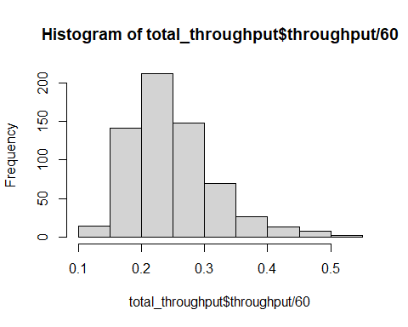

Histogram of checking time

hist(express_worker$activity_time/60)

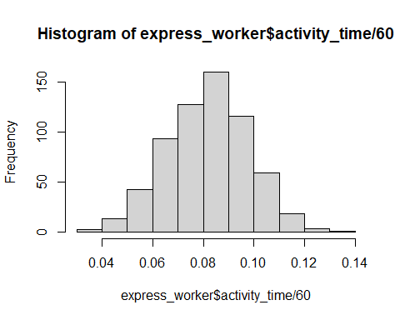

Histogram of admin time

hist(admin_worker$activity_time/60)

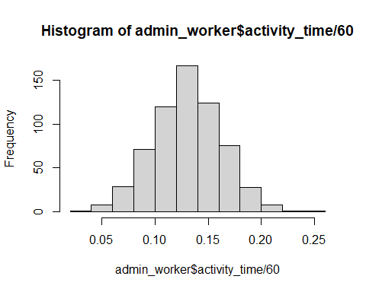

Histogram of wait time before checking

hist(express_worker_wait/60)

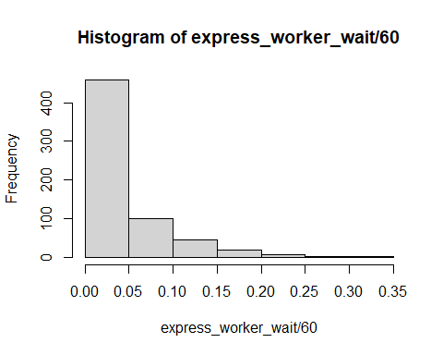

Histogram of wait time before admin

hist(admin_worker_wait/60)

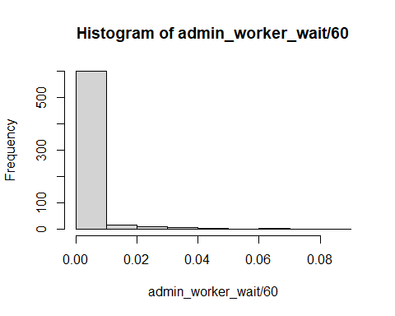

## (c) The proportion of parcels sent out in time. Please also state the simulated amount of parcels and the runtime.

Proportion of parcels sent out on time:

shipping_time <- 2*11*60  
shipped_in_time <- total_throughput %>% filter(throughput<= shipping_time)  
nrow(shipped_in_time)/nrow(total_throughput)*100

## [1] 100

Total number or parcels simulated:

nrow(total_throughput)

## [1] 634

Total runtime in hours:

sum(total_throughput$throughput)/60

## [1] 157.8866